Laptop / Fixed Assets Purchase Entry

Account Master (Create Account Under Fixed Asset)

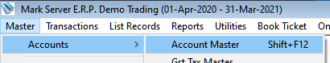

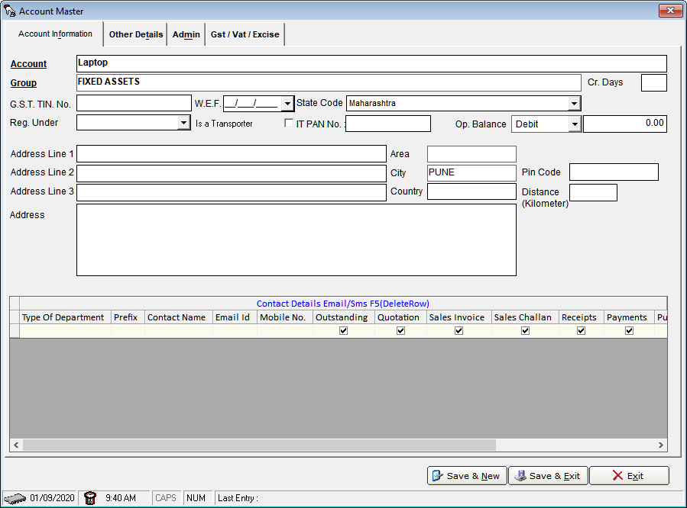

Save & New

Account Master (Create Account Sundry Creditors (Supplier))

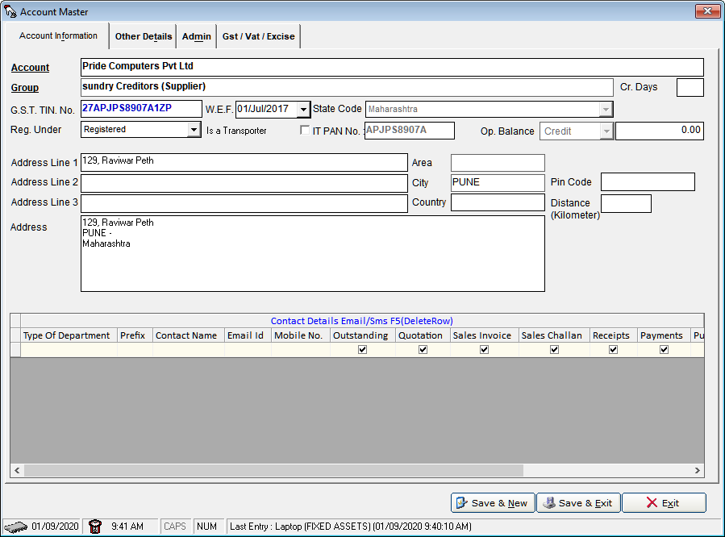

Product Master

============

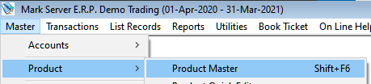

Create Product (Laptop)

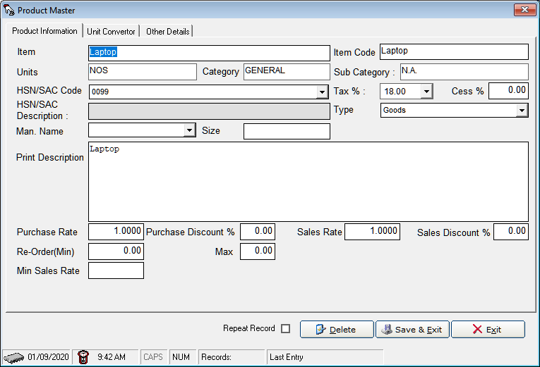

Purchase

